**Birla Institute of Technology and Science, Pilani**

Hyderabad Campus

**FIRST SEMESTER 2023-2024**

Course Handout

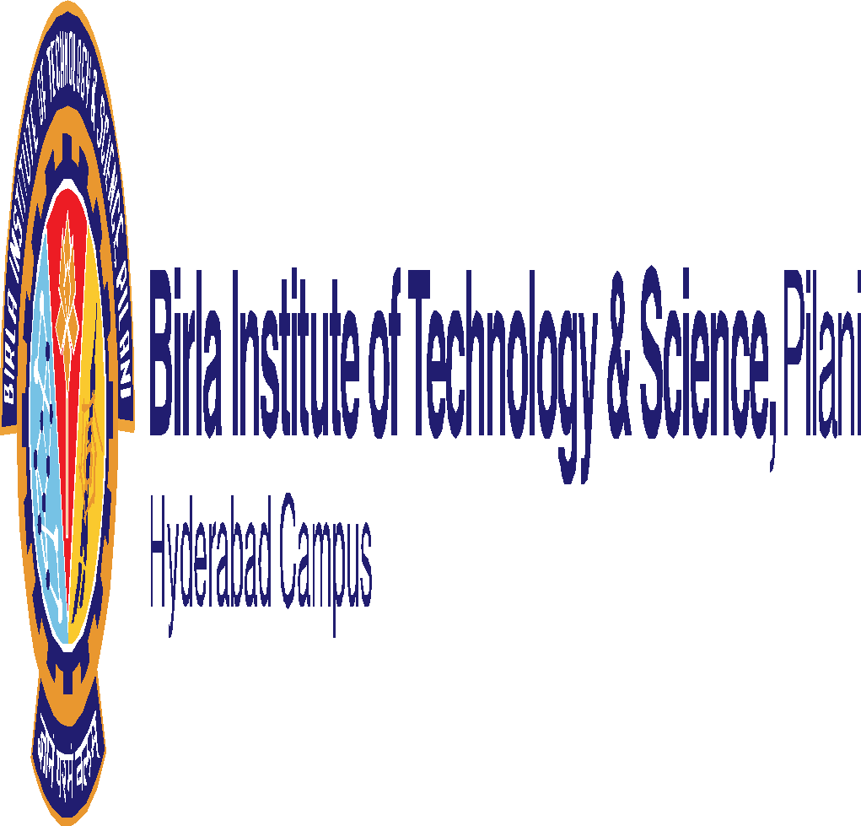



**Dated:11-08- 2023**

**Course No : BIO F313**

**Course Title : Animal Physiology**

**Instructor-In charge** **: Dr. PRAGYA KOMAL**

**Sharon Mariam Abraham**

**1. Course Description:**

Fundamentals underlying the working of tissues and organ systems in animals with emphasis on mammalian systems and integration of organ systems at the level of the whole organism. Important physiological systems will be taught such as respiratory, circulatory, nervous, endocrine, excretory, muscles, skeletal and reproductive systems.

**2. Scope & Objective:**

This course attempts to bring the awareness to the students regarding major features of physiological system in animals with focus on human physiology. Emphasis will be given to the function and adaptations as related to the survival of organisms in their ecosystem.

**Text Book:**

Sherwood, L., Klandorf, H. and Yancey, P.H., Animal Physiology: From Genes to Organisms, 2005, Brook/Cole Cengage Learning., Singapore

**Reference books:**

1.Sherwood L: Principles of Human Physiology. Brook/Cole Cengage Learning., Indian edition

2.Christopher D. Moyes and Patricia M. Schulte, Principles of Animal Physiology.2nd edition Pearson Education, 2016

**Course plan:**

|  |  |  |  |
| --- | --- | --- | --- |
| **Lect.** | **Learning objective** | **Topics to be covered** | **Ref. to Chapter** |
| 1-2 | Homeostasis and Membrane Physiology | Introduction to Physiology and  Homeostasis; Size and Scale among Organisms; Homeostasis is essential for proper cell function, and most cells, as part of an organized system, contribute to homeostasis; animals vary in their homeostatic abilities; Negative feedback is the main regulatory mechanism for homeostasis; Membrane Potential and Intercellular Communication and Signal Transduction | TB: Chap 1 &3  RB1: Chap 1 |
| 3-7 | Neuronal Physiology | How are electric signals generated and transmitted?  ; Introduction; graded and action potential; Chemical and electrical synapse; Neuromuscular synapse | TB: Chap 4  Review/research articles |
| 8-12 | The Vertebrate Nervous System: Overview and Peripheral System | Organization, parts, and functions of the Brain, and the spinal cord; cerebral cortex, memory, Learning, memory and sleep | TB: Chap 5  RB2: Chap 7 |
| 13-17 | How do we sense a stimulus? | Sensory Physiology; Different types of receptors and perception of the external and internal environment; mechanoreceptors; photoreceptors; chemoreceptors; Thermoreceptors; nociception | TB: Chap 6 |
| 17-21 | Support and movement of the body; | Muscles Physiology; Types of muscles and functions; Molecular Basis of Skeletal Muscle Contraction | TB: Chap 8 |
| 22-27 | Hormones and their function; How the Endocrine System Contributes to the Body as a Whole | Endocrine system; Vertebrate Endocrinology: Central Endocrine Glands; Cross talk between pituitary and hypothalamus | TB: Chap 7  Review articles |
| 27-31 | Self-maintenance and exchange of metabolites | Circulatory system; Circulatory vessels and Circulatory Pumps: Heart Electrical Activity (EEG); Integrated Cardiovascular Function | TB: Chap 9  Review/research articles |
| 31-34 | Breathing and exchange of gases; Gas Demands: General Problems | Respiration system; Breathing: Respiratory Mechanics in Mammals; Gas Exchange at Vertebrate Respiratory Organs and Body Tissues | TB: Chap 11 |
| 34-38 | Organ system and glands involved in food processing | Digestive system; General Aspects of Digestion; Digestive Accessory Organs: Pancreas, Liver, Gallbladder, Overview of the Gastrointestinal Hormones; Liver and Small intestine | TB: Chap 14 |
| 38-42 | Regulating the internal environment and removing the waste | Excretory system; Mammalian Urinary System: Overview and Glomerular Filtration; Mammalian Kidneys: Tubular Reabsorption; | TB: Chap 12  Research articles |

**Evaluation scheme:**

|  |  |  |  |  |  |
| --- | --- | --- | --- | --- | --- |
| Component | **Duration** | **Weightage %**  **(Total marks-200)** | **Date & Time** | **Venue** | **Remarks** |
| Mid Semester Test | 1.5 hrs. | 30 (60M) | 10/10 - 11.30 - 1.00PM | | CB |
| Multiple Quizzes | Variable | 30 (60M) | 3 Quizzes, the best 2 will be taken |  | CB |
| Comprehensive | 3 hrs. | 20 (40M)  20 (40M) | 08/12 AN | | CB  OB |

**OB- Open Book**

**Chamber consultation hour**: To be announced in lecture class hour.

**Notices:**

All notices/ announcements regarding this course shall be displayed in Course Management System

**Grading policy:** Award of grades will be guided in general by the histogram of marks. Decisions on borderline cases will be taken based on the individual’s sincerity, the student’s regularity in attending classes, and the instructor’s assessment of the student.

**Make-up policy:**

Make-ups will be granted for mid-semester examinations or comprehensive examinations only if the candidate is found seriously sick. **A request letter for the same must be provided by the student with the parent’s signature on it, supplemented with an on-campus doctor’s prescription**. **No make-up will be granted for quizzes under any circumstances**.

**Academic Honesty and Integrity Policy**:

Academic honesty and integrity are to be maintained by all the students throughout the semester and no type of academic dishonesty is acceptable.

#### Instructor-in- charge

**BIO F313**